Skills Workshop #5 : Ethics in Research Workshop
Speaker: Dr. Nora Honken
Date: June, 19, 2019
Time: 11:00-12:00 pm
Venue: Baldwin 741
Prepared by: Megan Brown, Newport High School, Newport, KY
RET Participants for Project #1 Engineering Aligned, Bioactive Polymers for Peripheral Nerve Repair

This session was given by Dr. Nora Honken from 11:00 am-12:00 pm. at the University of Cincinnati in Baldwin Hall, room 741. Dr. Honken’s focus of her session was to speak about Research Ethics and the different situations that constitute misconduct and unethical behavior.

Dr. Honken started off the session by speaking about herself and her work as seen Figure 1. Dr. Nora Honken is an assistant professor in the Engineering Education Department at UC. She is a part of the Institutional Review Board at UC and reviews the ethics of research projects. She earned her BS in Industrial Engineering and Operational Research from Virginia. She earned her MS in Industrial Engineering from Arizona State University. Finally, she earned her PhD in Educational Leadership and Organizational Development from the University of Louisville. Before teaching, Dr. Honken held engineering and management positions at Corning, Amoco Performance Products, Varian, and Axxess Technologies.
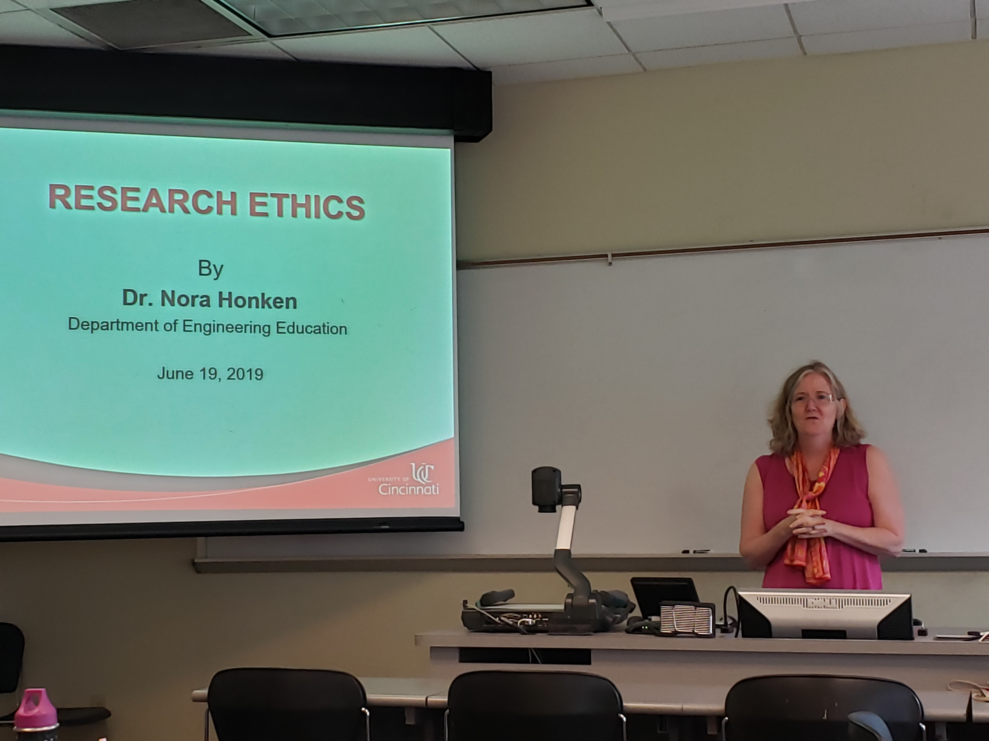
Figure 1: Dr. Nora Honken giving her introduction and speaking about her current work at UC to help engineering student retention.

Dr. Honken first discussed what the field of ethics is, as seen in Figure 2. She then discussed the difference between misconduct and unethical behavior. Misconduct is an action like plagiarism, falsification, fabrication, or any other deliberate action taken to mislead someone about a research project. Most cases of misconduct are offenses that require some consequence. Unethical behavior is different; it is not always intentional or punishable. Unethical behavior includes: not disclosing conflicts of interest and violations of standard cultural norms and ethics. Dr. Honken stressed the importance of always understanding where unethical behavior and misconduct can occur in the research process; as the burden of proof of innocence falls on the researcher. Possible actions that can be taken against researchers who are found to have committed unethical behavior or misconduct are as follows: debarment, ligation, jeopardizing funding for the entire institution, or termination of your position.

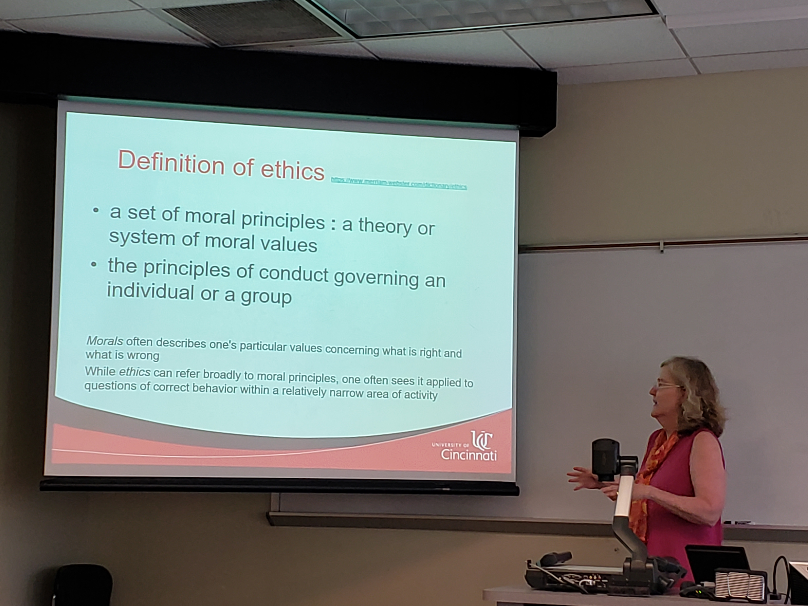
Figure 2: Describing the definition of ethics
The second topic of discussion was how to ethically determine authorship of manuscripts produced in a lab setting, as this is a possibility in our labs. Dr. Honken described the requirements for being considered a co-author on a manuscript. To be considered a co-author, an individual must take part in the execution or planning of the research project, contribute to the writing or revision of the draft of the manuscript, and must also participate in the final review before publication. Dr. Honken suggested that the RET teachers should speak with their labs to take on more responsibilities in the writing of a manuscript in order to meet these requirements to be considered a co-author. This information was geared more toward the RET teachers who work at the university level.

Finally, Dr. Honken spoke about her role on the IRB, institutional review board, and the importance of an internal team reviewing research projects. She gave several case study examples of what can go wrong when there are no “checks and balances” at the institutional level. For example, Dr. Honken referenced the Tuskegee Syphilis study to emphasize the importance of informed consent when working with human subjects. Dr. Honken also spoke about the case study of Andrew Wakefield and the other 11 co-authors who wrote about the link between autism and vaccines. The research was later found to be fabricated and the paper was redacted from Nature. This came with serious consequences for Mr. Wakefield and several of the other co-authors including debarment for Mr. Wakefield. Dr. Honken used this as an example of the severity of what can happen when you falsify research -- it affects more than just the researcher.

